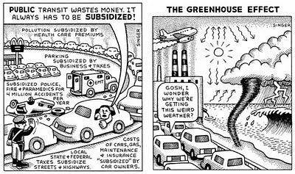

“Carbon Emission from Cars”- project

Data Pre-processing and carbon emission estimation model building ptoject

Suvojyoti Mitra | PGDM-Big Data Analytics | IISWBM, Kolkata | isin151606